NYIT  
College of Computer Science  
Dept. of Computer Science

CSCI 455 - M01  
StudyBud  
  
By Team:

* Allen Lin 1075910

- Brian Fitton 1022993

- Qijun Liang 1073366

- Anil Kandhai 1020630

- Jarman Liu 1061263

Table of Contents

* Abstract Pg. 3
* 1.0 Introduction Pg. 4
* 1.1 Motivation Pg. 4
* 1.2 Existing Products Pg. 4
* 1.3 Proposed System Pg. 4
* 1.4 Purpose Pg. 4
* 1.5 Users Pg. 4-5
* 1.6 Tools + Technology Pg. 5
* 1.7 Final Goals + Objective Pg. 5
* 2.0 Analysis of Project Pg. 5-6
* 2.1 Diagram of Project Pg. 6-7
* 3.0 Implementation Pg. 7
* 4.0 Timeline and Explanation Pg. 7
* 5.0 Members Pg. 8
* 5.1 Tasks Pg. 8
* 5.2 Strengths and Weaknesses Pg. 8
* 6.0 Conclusion Pg. 9
* 7.0 References Pg. 9

This project will be an attempt to improve upon an already existing model in education, by integrating some pieces of social media and other types of social programs to create a more inviting experience for users and a more convenient platform for study and teaching. The User Interface will be one part of the project that we will work on to be more user friendly and easy to figure out for any end user that will access our program, so that they can easily navigate through the available classes or create one on their own, so that they may start a topic for study or start a lesson if the user is a teacher. Administrators will have their own accounts to be able to moderate the users and the types of topics that are currently being created so that none are created which go against the intended purpose of the platform, or to delete any derailed or done topics to keep the UI from being completely cluttered. Another heavy emphasis will be on possibly adding a voice chat integration or a fast paced messaging integration, in which one can sign in using something such as Facebook Messenger or Google to link the accounts and therefore only use one sign in method to get access. This can be expanded to include a school’s database system as well to make it easier for educators to host a class and then provide a grade for the students in their class. The grades and other information from quizzes and other things such as review questions and sample tests will be available in the data upon the user’s request, with possibly two types of grades, one for “Peer Reviewed” and the other for “Educator’s Grade” so that you can see the clear difference in what the teacher says is the correct material and what students can agree on where you went wrong, to create a more dynamic and communicative education experience between both student and teacher. The study rooms can also come with a “Request for Help” which will allow a user with a teacher account to be able to see which study rooms require help, and can enter that room to help out the students inside with any questions they may have. This can also be used to call for an admin to report abuse if needed, as abuse of this system will result in a system ban.

1.0 - Introduction

The project that we are working on is an improvement on systems like blackboard, Quizzlet, and other types of online education or learning systems. This would be different as it would allow one to filter through specific educational topics and create or join a study session with interactive flash cards and quizzes along with notes based on that one topic, while also being in a group message with other students, or even a teacher, who are studying/teaching that topic. This would allow students to learn from each other or a teacher in order to understand specified topics.

1.1 - Motivation

The motivation for this project comes from after seeing many types of review systems, and through doing our own study sessions online via other methods, there was no decent middleground between the two. We decided to take a new stance on this and try to incorporate a few things from these existing study outlets and mix them with programs that we could use in everyday, such as Skype, Zoom, Discord, or Facebook Messenger, to allow easier communication between peers while helping each other study or understand material.

1.2 - Existing Products

Some existing Products would be Quizzlet, GoToMeeting (as an example of a meeting type software), and Blackboard (as a information gathering and sharing hub). While some of these have huge assets in Information Sharing, communication, and study session and lesson planning, these only have one of these features and not all of them for the convenience of the user.

1.3 - Proposed System

Our proposed system would add together the UI and features of these existing products, while seeking to add in a more dynamic filtering system and easier to navigate UI. Integrating with Google, Facebook, or other types of social media in order to allow users to maintain a saved profile and monitored profile, users would be able to select a topic of study, take quizzes on that topic, obtain notes on that topic and communicate with others also interested or studying that topic all at the same time on one platform.

1.4 - Purpose

The reason why we decided to create this project is to improve on and to enhance already existing systems into something that can eventually become a standard in many schools of different grade levels from K-5 to College level.

1.5 - Users

There will be two types of users, a teacher’s and a student, the teacher will be able to host a class, or be able to review work and material submitted by the students, and students are able to create topics for study, and create and take notes and quizzes and share them among each other. An admin account will be used to moderate the topics and monitor the accounts being registered.

User Permissions:

Student:

* Access to topics and texts
* Able to create flash cards
* Able to create study sessions
* Able to join study sessions or lessons
* Able to “Peer Review” other people’s work (give a rough peer grade)
* Able to use “Help Me” feature to request a teacher
* Able to file share between student and teacher

Teacher:

* Access to topics and texts
* Able to create flash cards
* Able to create study sessions or lessons
* Able to weigh in upon request on study sessions at a student’s request (Request from student at “Help Me” option)
* Able to “Educator’s Review” other people’s work (Give a more firm and high standing grade)
* Able to view student information to see areas of needed improvements and current “Peer Grades” and “Educator’s Grades”
* Able to file share between student and teacher

Admin:

* Handle assigning permissions
* Delete any off topic threads
* Moderate the community
* Make sure the system runs properly

1.6 - Tools + Technology

* Android Studio (Will possibly use to enable mobile capability and allow this to be used on mobile devices)
* MySQL Database(To store the data and information of the users and the different subjects that are all available)
* FireBase for possible Data storage as alternative

1.7 - Final Goals and Objectives

The end result would be a system that can be used and fully able to be integrated with multiple social medias and be both mobile and web accessible for both student and teacher access. This will also include a database of topics and different classes that are currently available. This would be manifested through an android application as well as a website.

2.0 - Analysis of Project

The project will be done over multiple stages with multiple layers of work, it will be able to integrate with a database and user information to create a proper UI. There will be a proper front end and constant communication between the end user and the database to ensure that the correct information is being relayed to the correct party, and as such is being updated in kind by the same information and user that is accessing it. This data will be shared to those who access the system and can also be shared from user to user.

2.1 - Diagrams of Project

(DFD or State Diagram of project (Labeled as Figure 1, Figure 2, etc)

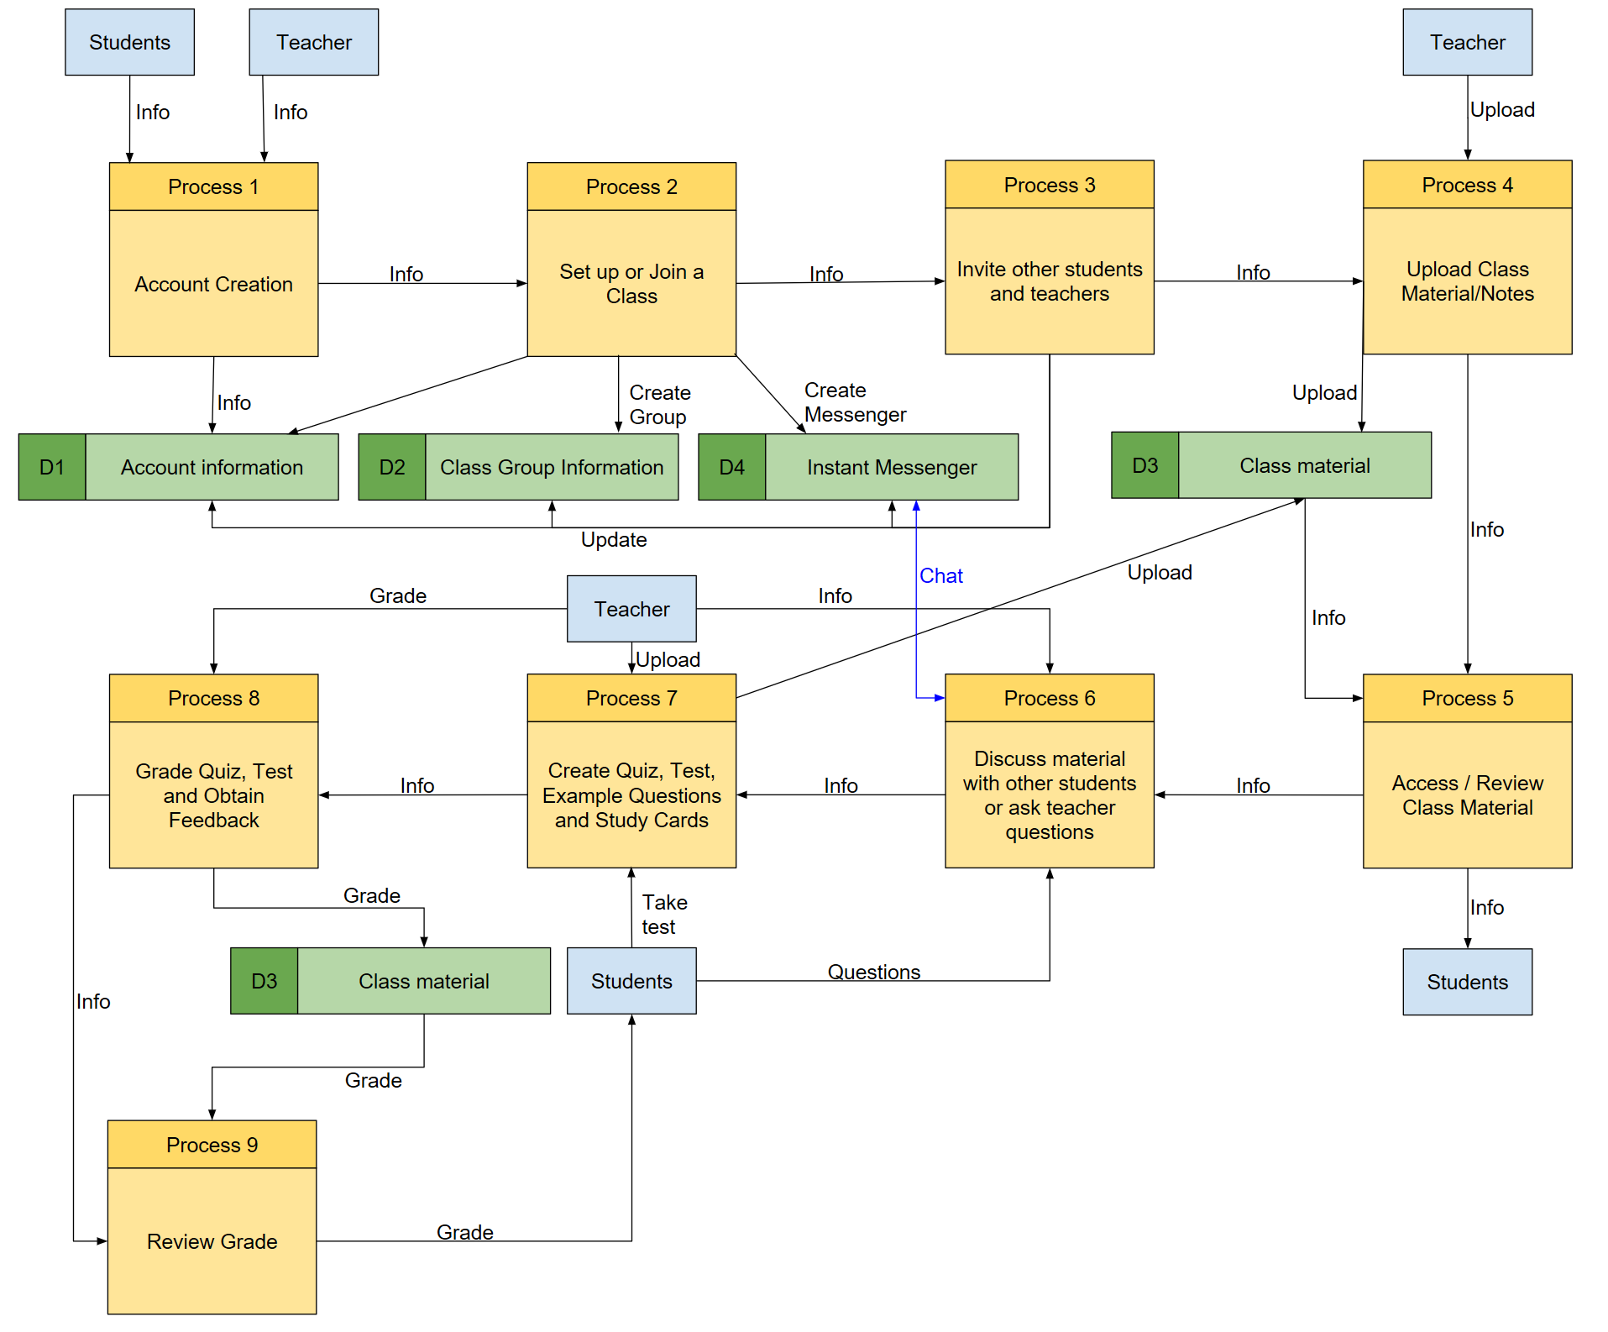

The project can be analyzed and/or further defined by using a Data Flow Diagram or State Diagram to get a better scope of what the project should be capable of. This will allow us to gauge the time that will be put into the project and how each part of the project will interact with each other to properly evaluate the steps during development.

3.0 - Implementation

We will be using MySql for the database and information, and Android Studio for the UI development to make the program be user friendly and mobile device friendly. We will be testing the compatibility using our own android devices, and possible Apple devices depending on time. We would also have a website which would carry out the same functions only on a desktop setting. The reason for using MySql for database is it is something that we are very familiar with using, and is a good way to keep all the different tables organized and separated so that it can be easier to retrieve and store the information.

4.0 - Timeline and Explanation

Week 1 - 3 planning project

Week 3 - 5 design

Week 5 - 12 front and back end development

Week 12 - 16 testing and evaluating the project

|  |  |
| --- | --- |
| Dates | Objective |
| 1/30/19 - 2/13/19 | Planning Project |
| 2/13/19 - 2/27/19 | Design |
| 2/27/19 - 4/17/19 | Front end and Back end development |
| 4/17/19 - 5/1/19 | Testing and evaluation of the project |
| 5/1/19 - 5/8/19 | Review and Improve project based on tests |

5.0 - Members

* Allen Lin 1075910 (Leader)
* Brian Fitton 1022993 (Member 1)
* Qijun Liang 1073366 (Member 2)
* Anil Kandhai 1020630 (Member 3)
* Jarman Liu 1061263 (Member 4)

5.1 Tasks of each Member

* Allen Lin 1075910 : Manage schedule, assist with front and back end programming
* Brian Fitton 1022993: Assist with front end, back end coding and implementation
* Qijun Liang 1073366 : Java back end and SQL work
* Anil Kandhai 1020630: Testing front end and back end, SQL work, and database connectivity
* Jarman Liu 1061263: Front end

5.2 Strengths and Weaknesses

:

* Brian Fitton 1022993 Strengths: Good with UI development and planning, Able to read and understand MySQL and Java; Weaknesses: Debugging, Connecting code with other systems
* Allen Lin 1075910 Strengths: proficient in Java and front end development; Weaknesses: debugging code programmed separately
* Qijun Liang 1073366 Strengths: Able to do Java development and python ; Weaknesses: Database
* Jarman Liu 1061263 Strengths: Python, Front end (HTML, CSS), Java;

Weaknesses: Database

* Anil Kandhai 1020630 Strengths: Able to do Java development and basic experience with python. Good working with databases and proficient with MySQL

Weaknesses: Experience and linking code with other systems

6.0 - Conclusion

While improving on the current systems we hope that our project will be one that stands out as a truly unique experience for both students and teachers alike compared to other lesson planners and study programs that currently exist. Looking to modernize and expand upon the already effective methods will be our main goal for the project and how we plan for it to be something that can catch the consumer eye and stand above all others. While the most difficult part of this development process may prove to be the integration with both Apple and Android, along with the social media integration, with time permitting. We have high hopes for the development cycle of this program and the end result of the finished product.

7.0 References

* <https://www.mystudylife.com/>
* <https://www.studyblue.com/>
* <https://www.studystack.com/>
* <https://discordapp.com/>
* <https://quizlet.com/>